**Building a Culture of Continuous Learning and Development**

The rapidly evolving business landscape has emphasized continuous learning and development (L&D) as a cornerstone of corporate success. With technological advancements, shifting skill requirements, and the need for innovative solutions, organizations that fail to foster a culture of continuous L&D risk falling behind in the competitive marketplace.

This article delves into the importance of building a continuous L&D culture, its benefits, practical ways companies can implement learning & development programs, and factors contributing to a successful implementation.

## **The Importance of Continuous L&D**

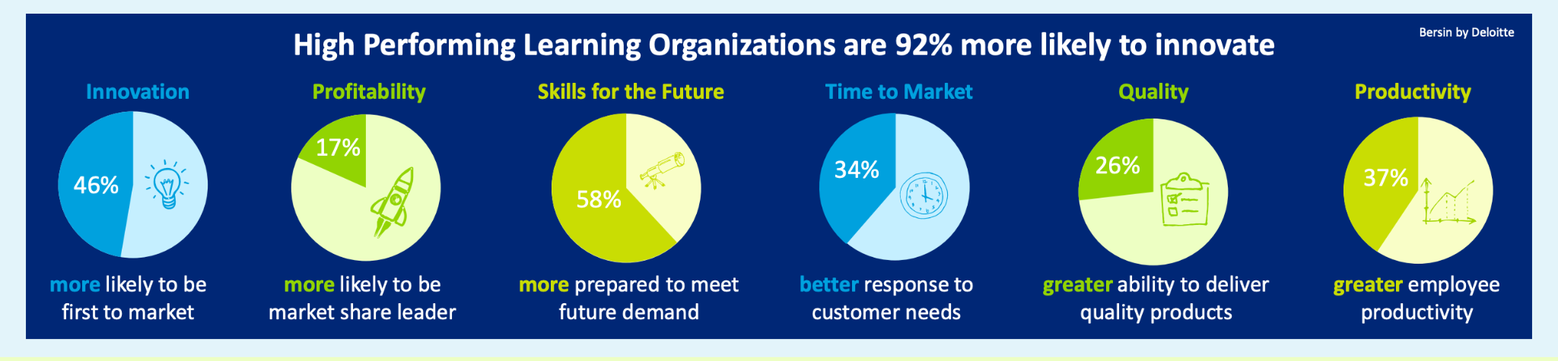

A strong connection exists between a robust learning culture and the overall success of a business. Deloitte's [Leading in Learning](https://www2.deloitte.com/content/dam/Deloitte/global/Documents/HumanCapital/gx-cons-hc-learning-solutions-placemat.pdf) report highlights that organizations emphasizing continuous learning are 46% more likely to be market leaders, achieve a 37% increase in productivity, and exhibit a 92% greater likelihood of innovation. Beyond these remarkable figures, fostering a continuous learning environment renders a company an attractive workplace. Consequently, a continuous learning culture not only draws top talent but also aids in retaining it. Providing employees with ongoing learning opportunities has a direct impact on retention. According to a survey, when employees feel that their employer is investing in their professional growth and development, they are between [30-50%](https://login.bersin.com/Login.aspx?p=http://bersinone.bersin.com/resources/research/?docid=103312171&h=1) more likely to remain with the organization for a longer duration of time. It is important to treat talent as a valuable and replenishable asset, not only as a means of showing appreciation for employees but also because it can be more cost-effective than constantly recruiting and training new hires.

Overlooking the significance of learning leaves employees ill-equipped to navigate rapid workplace changes and [the diminishing longevity of skills](https://www.bcg.com/publications/2021/create-competitive-advantage-with-organizational-learning). In the past, talent sought employment to master a specific role, but nowadays, [learning is the job](https://hbr.org/2021/11/make-learning-a-part-of-your-daily-routine). Adaptive and proactive learning is a highly valued trait, resulting in long-term benefits for career advancement. Companies must foster an environment that values employees, enhances retention, and achieves business success.

As we delve deeper into the significance of nurturing a continuous learning and development culture, it is essential to highlight the various aspects that contribute to its importance:

### **Nurturing Talent**

Enhancing employees' skills, expertise, and capacities is vital in retaining existing top performers and attracting new ones. By cultivating a culture of continuous learning and development (L&D), organizations can showcase their dedication to supporting the professional growth of their workforce.

This, in turn, results in increased employee engagement, satisfaction, and allegiance to the company, as individuals recognize that their personal and professional development is valued and prioritized.

### **Adapting to Change**

Organizations need to exhibit agility and adaptability in an era characterized by swift advancements in technology, fluctuating regulations, and ever-shifting market conditions.

Employees are empowered to remain current with prevailing trends, leading industry practices, and novel innovations by embracing a continuous learning and development culture. This fosters a spirit of ingenuity and ensures that the organization maintains its competitive advantage.

### **Enhancing Performance**

By adapting to a culture of continuous learning and development, organizations can experience a notable improvement in overall performance. As employees acquire new skills and knowledge, they become adept at working more effectively and streamlining processes. Additionally, they develop the ability to identify areas of concern or potential vulnerabilities within the organization.

This heightened awareness enables them to create targeted solutions that address pressing challenges and bolster the company's position in the face of adversity.

## **Benefits of a Continuous L&D Culture**

Embracing a culture of continuous learning and development benefits individual employees and strengthens the organization as a whole. The following section outlines the advantages of fostering such a culture.

### **Employee Engagement**

When employees perceive that their organization genuinely values them and identify a clear path for personal and professional growth, they are more inclined to engage in their work actively.

This level of engagement has a domino effect on various aspects of the organization, including a surge in overall productivity and a decrease in employee turnover. This is a testament to the positive impact that a culture of continuous learning and development can have.

### **Collaboration and Innovation**

Cultivating a culture of continuous learning and development promotes an environment that fosters cross-functional collaboration and encourages individuals to work together to solve complex problems. As employees share their knowledge, expertise, and unique perspectives, they collectively contribute to the development of innovative solutions that have the potential to propel the business toward greater success.

By nurturing this collaborative atmosphere, companies can unlock the full potential of their workforce and better navigate challenges.

### **Stronger Talent Pipeline**

By dedicating resources to continuous learning and development initiatives, organizations are better equipped to pinpoint high-potential employees with exceptional aptitude and promise for future growth. By honing the skills and expertise of these individuals, companies can effectively cultivate a robust pipeline of talent that can be tapped into for filling leadership positions and other critical roles within the organization. This strategic investment in human capital not only supports the professional growth of high-potential employees. It also safeguards the company's long-term stability and success.

## **Practical Ways to Exhibit Continuous Learning & Development**

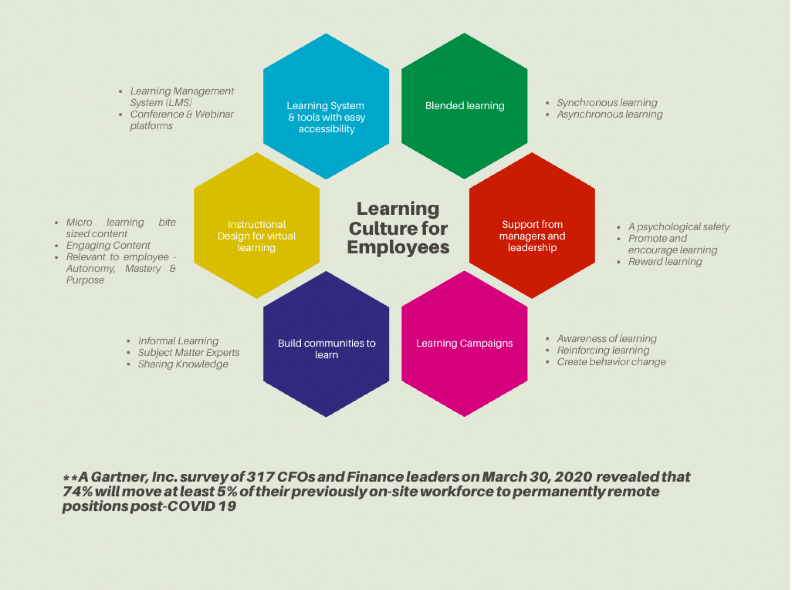

[Source](https://www.peoplemattersglobal.com/blog/training-development/how-to-build-a-learning-culture-for-remote-employees-27692)

As we explore methods for demonstrating continuous learning and development, it is essential to outline practical approaches that can be applied in various professional contexts:

### **Structured Learning**

Structured learning encompasses how learners acquire new knowledge and abilities through pre-established, organized learning initiatives designed to achieve specific understanding objectives. These may include:

#### Higher education courses from universities or colleges

#### In-house training programs

#### External workshops or conferences

#### e-Learning courses

#### Mobile learning courses

#### Massive Open Online Courses (MOOCs)

### **Collaborative Learning**

Collaborative learning covers how learners interact, converse, collaborate, and learn from others to expand their knowledge or acquire new skills. This can be both formal and informal, comprising:

#### Engaging in discussions and collaborations on social media

#### Discovering blogs or additional resources for deeper insights

#### Collaborating with colleagues

#### Participating in coaching and mentoring programs

#### Receiving on-the-job training

### **Independent Learning**

The process of acquiring new skills or enhancing one's knowledge and comprehension can extend beyond formal training or collaboration with others. Independent learning can involve:

#### Conducting research and reading to gain a profound understanding of a subject

#### Listening to relevant podcasts or watching instructional videos

#### Experimenting and exploring new concepts or techniques

## **Factors Contributing to Successful Implementation**

As organizations strive to establish a continuous learning and development culture, it is critical to recognize the key factors that contribute to the successful implementation of such an approach:

### **Leadership Commitment**

The visible support and promotion of continuous learning and development initiatives by senior leaders are essential in setting the stage for a thriving learning culture within an organization. When leaders prioritize employee growth and development, they show their dedication to cultivating a workplace culture that values ongoing progress and improvement. This visible endorsement also ensures that adequate resources, including time, funding, and human resources, are allocated to support the successful implementation and sustainability of the continuous L&D programs.

### **Alignment with Business Objectives**

Learning and development programs within an organization should be strategically aligned with the company's overarching objectives, ensuring that they contribute directly to attaining its long-term goals. By designing these programs to bolster employees' capacity to contribute meaningfully to the organization's overall success, companies can optimize the return on their investment in human capital. This focused approach to L&D fosters a strong sense of purpose among employees and reinforces the critical link between individual growth and collective achievement.

### **Personalized Learning Experiences**

To maximize the effectiveness of a learning and development strategy, it is essential to accommodate the diverse learning preferences of employees within the organization. By providing access to a wide range of learning materials in various formats, such as videos, articles, and interactive modules, companies can facilitate a more inclusive and engaging learning experience. Additionally, allowing employees the flexibility to progress through these materials at a pace that suits their unique needs and schedules further promotes an environment conducive to personal growth and professional development.

### **Measurement and Evaluation**

It is vital to periodically evaluate L&D’s impact on both employee performance and broader business outcomes. Companies can identify areas that may require further attention or improvement by conducting regular assessments of these programs, allowing them to fine-tune their approach to better align with organizational goals. This commitment to continuous evaluation and refinement enhances the overall efficacy of L&D initiatives and demonstrates the organization's dedication to maintaining a dynamic and responsive learning culture.

## **To Sum It Up**

By nurturing talent, fostering innovation, and enhancing performance, companies that invest in continuous L&D will benefit from higher employee engagement, a more substantial talent pipeline, and increased organizational agility. Organizations must embrace the importance of constant L&D and strive to build a culture that prioritizes employee growth and development as a strategic imperative for sustainable success.